Pain Questionnaire

Name: _________________________________________________ Date: ________________________
Using the appropriate symbols, please indicate on the figure the location and sensation of your pain today.  Right Left Left Right  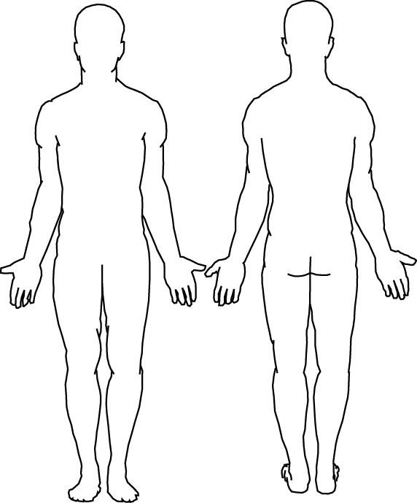  Front Back  Numbness Pins & Needles Burning  - - - - - - - - - o o o o o o o o o x x x x x x  Stabbing Aching Throbbing  / / / / / / / ^ ^ ^ ^ ^ ^ ^ ^ * * * * * * | What is your pain intensity on a zero to ten (0-10) scale?  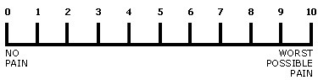  Current level of pain? ______  Average daily level of pain? ______  Greatest daily level of pain? ______  Least daily level of pain? ______  State your problem – What, When, Where, and How?  ________________________________________________  ________________________________________________  ________________________________________________  ________________________________________________  Is your pain increased by any of the following?  ❑ Standing ❑ Walking ❑ Bending  ❑ Sitting ❑ Lying Down ❑ Twisting  ❑ Lifting ❑ Exercise  ❑ Other: ________________________________________  Is your pain relieved by any of the following?  ❑ Sitting ❑ Lying Down ❑ Standing  ❑ Medications ❑ Exercise ❑ Postural Change  ❑ Other: ________________________________________

